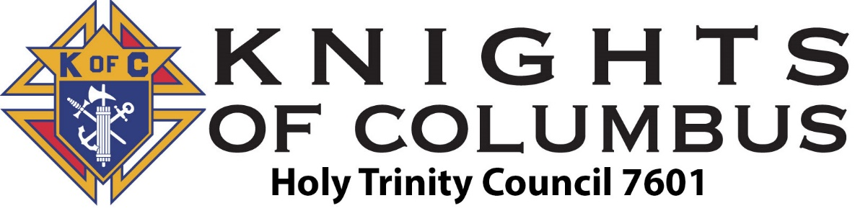
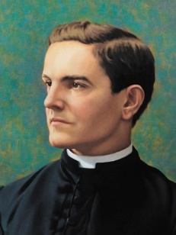

March 2026

2nd – Rosary for Life (6pm)
2nd – Member’s Meal (630pm)
2nd – Holy Trinity Hall Inc Meeting (720pm)
2nd – Member’s Meeting (730pm)
6th – Fish Fry (5pm)
8th – Daylight Savings Time Begins
(clocks go forward 1 hour)
13th – Blood Drive (4pm)
13th – Fish Fry (5pm)
17th – St. Patrick’s Day
20th – Fish Fry (5pm)
23rd – Planning Meeting (7pm)
24th – 4th Degree Meeting (730pm)
17th – Annunciation Of The Lord
27th – Homeless Shelter
27th – Fish Fry (5pm)
29th – Palm Sunday

April 2026

2nd – Holy Thursday
3rd – Good Friday
5th – Easter
6th – Rosary for Life (6pm)
6th – Member’s Meal & Meeting (630pm)
12th – Divine Mercy Sunday
27th – Planning Meeting (7pm)
28th – 4th Degree Meeting (730pm)

May 2026

4th – Rosary for Life (6pm)
4th – Member’s Meal & Meeting (630pm)
Nomination of KofC Officers
10th – Mother’s Day
14th – Ascension of Jesus*
18th – Planning Meeting (7pm)
19th – Georgia Primary Election
24th – Pentecost
25th – Memorial Day
26th – 4th Degree Meeting (730pm)

Email 7601gk@gmail.com
Website www.kofc7601.org
Facebook Page www.facebook.com/groups/KofC7601/
Golf Tournament Website www.7601charitygolf.com

Italicized items are non-Knights events that are of interest to us.

